Clean up local master
git checkout master
git reset --hard origin/master

this will
delete all the new files created
undo all the new work in existing files

git checkout -b feature/add-test-file

write the code in Eclipse

git status

will show the file names where changes are made in red color

git add .

git status

will show the file names where changes are made in green color

git commit -m “”

git push -u origin feature/add-test-file

goto github.com/repo

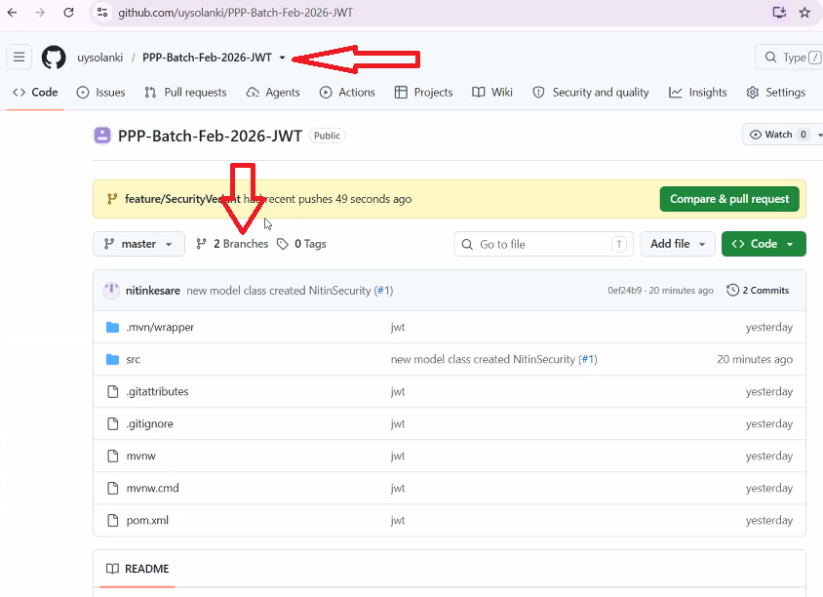

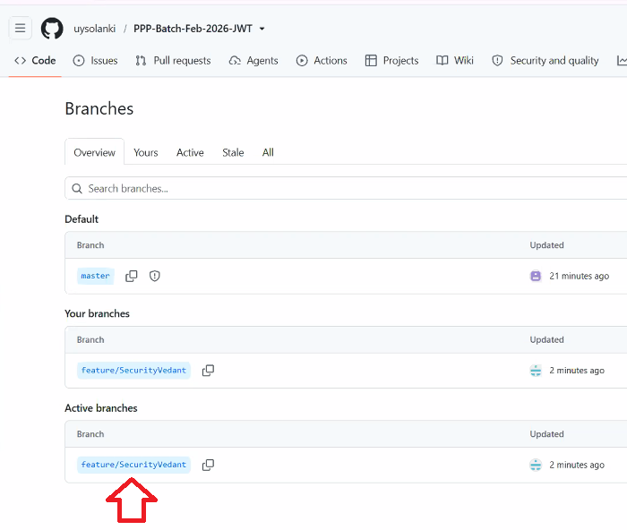

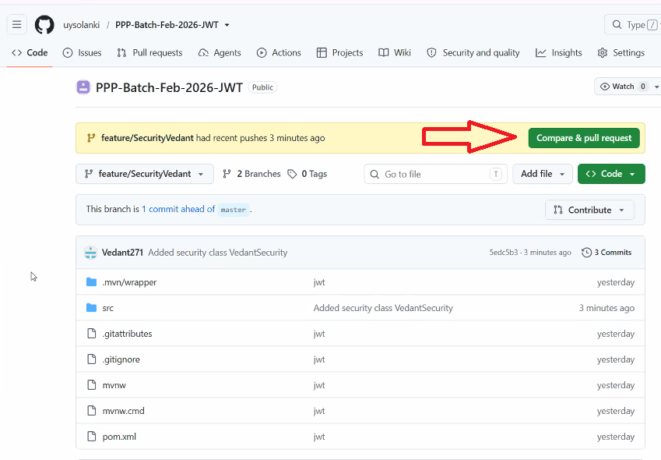

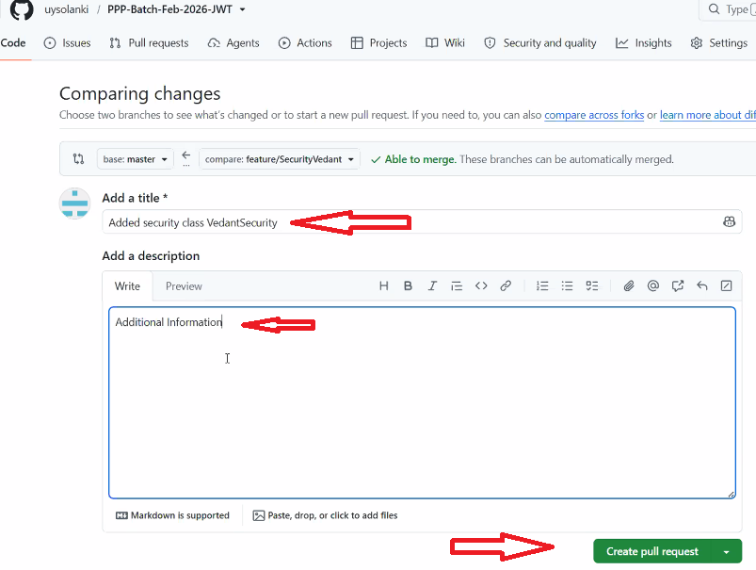

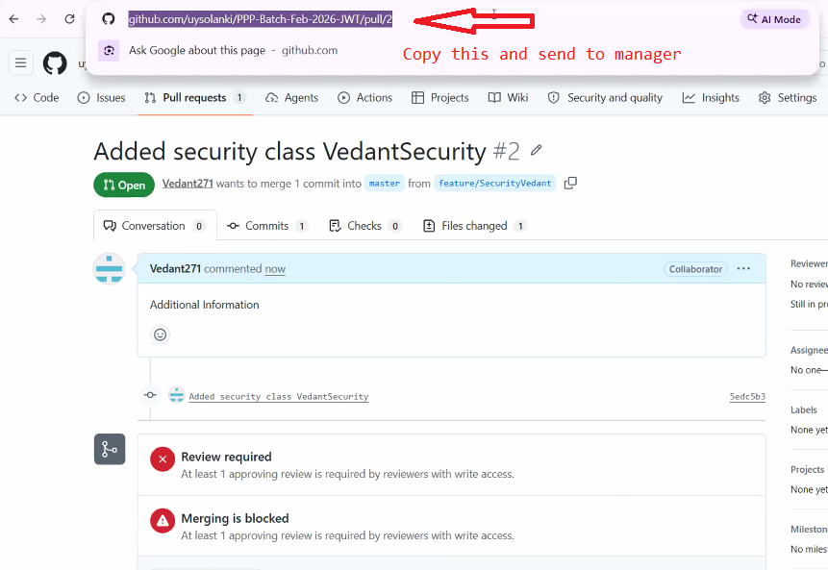

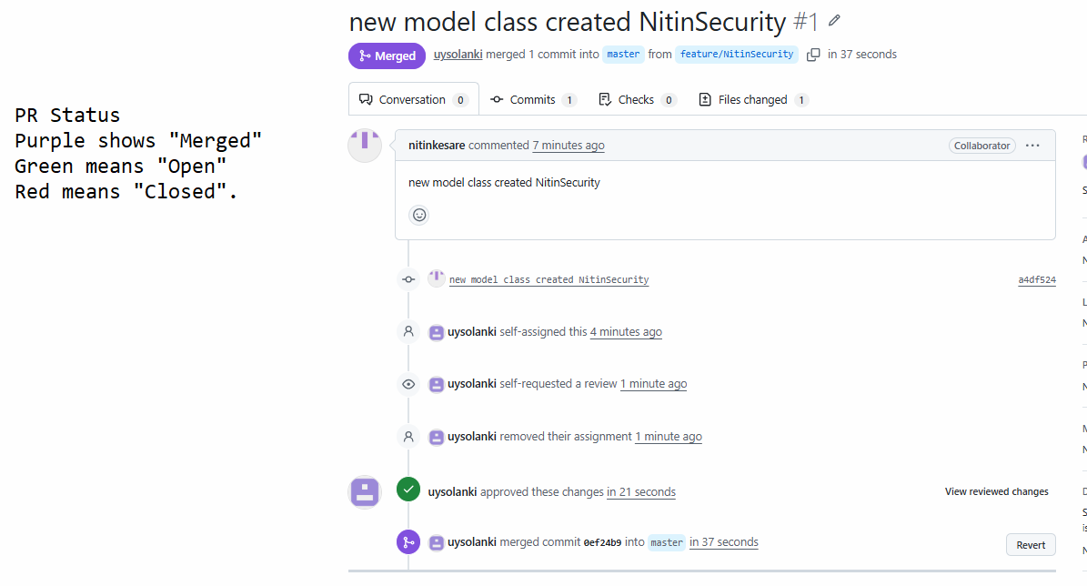

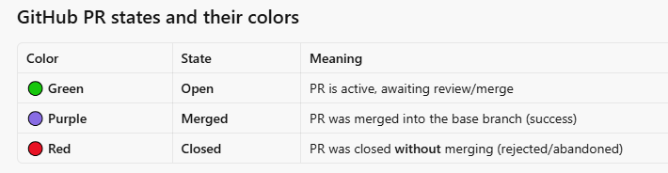

After merging delete the branch on
- Github (by manager)
- Local git bash(by programmer)
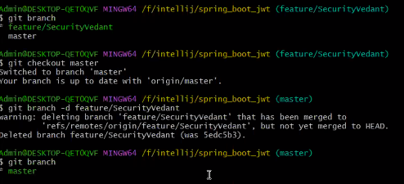

After any PR is merged, every developer should sync their local master so everyone is working on top of the latest code. This is the key habit that prevents conflicts later.

What each developer runs
git checkout master
git pull origin master

If Developer is in the middle of work on a feature branch
They should not abandon their branch. Instead, update master first, then bring those updates into their branch:
# 1. Update local master
git checkout master
git pull origin master
# 2. Go back to their feature branch
git checkout feature/their-task
# 3. Bring the latest master into their branch
git merge master

